A COMPARATIVE ANALYSIS OF ISOLATION FOREST AND LOCAL OUTLIER FACTOR FOR ANOMALY DETECTION IN HEALTHCARE PROVIDER DATA: AN APPLIED STUDY
Nyan Lynn Htet ^{1 *}, Deshinta Arrova Dewi², Marwan Alshare³, Mun San Chye ⁴
^{1 *,2}Faculty of Data Science and Information Technology, INTI International University, Nilai, 71800, Malaysia.
²Faculty of Engineering and Technology, Shinawatra University, Thailand 99, Bang Toei, Sam Khok District, Pathum Thani 12160, Thailand
³Faculty of Computing & Information Technology, Sohar University, Oman. 3111 Al Jamiah Street, Sohar 311, Oman
⁴Faculty of Education and Liberal Arts, INTI International University, Nilai, 71800, Malaysia.
Corresponding author’s e-mail: * nyan.contact@gmail.com
 | ABSTRACT
Article History: | The integrity of healthcare systems is a cornerstone of public well-being, yet it is consistently threatened by anomalies such as billing errors and fraudulent activities. Detecting these irregularities is crucial for financial stewardship and supports global health initiatives like the UN Sustainable Development Goals. This study presents a comparative analysis of two prominent unsupervised machine learning algorithms—Isolation Forest (IF) and Local Outlier Factor (LOF)—for detecting anomalies within a large-scale healthcare provider claims dataset. The methodologies were applied to a dataset of 100,000 records, followed by a rigorous quantitative and statistical comparison of the resulting anomaly sets. Our findings reveal a low overlap between the anomalies detected by IF and LOF (Jaccard Index < 0.06), indicating that each algorithm identifies distinct types of outliers. Statistical validation using the Mann-Whitney U and Chi-square tests confirmed that the anomalies identified by each model possess significantly different characteristics from normal data and from each other (p < 0.001). This research underscores the complementary nature of these algorithms and advocates for a multi-model approach to achieve a more comprehensive and robust anomaly detection framework in healthcare, thereby enhancing institutional accountability and resource efficiency.

Received: date month year
Revised: date month year
Accepted: date month year

Published: date month year

Keywords:
Anomaly Detection; Healthcare Data Mining; Local Outlier Factor; Statistical Computation;
Process Innovation

 | This article is an open access article distributed under the terms and conditions of the Creative Commons Attribution-ShareAlike 4.0 International License (https://creativecommons.org/licenses/by-sa/4.0/).

INTRODUCTION
Recent digital technologies adaptation in the field of healthcare creates large amounts of data that present an enormous potential to enhance the care of patients and their overall operations. This data-rich environment, however, creates key problem issues as well, especially with regard to data integrity. Healthcare providers send data with a variety of anomalies with the potential to threaten the stability and reliability of the healthcare systems at a substantial degree [1]. Strict and on-time detection of these outliers is essential in terms of protecting financial assets, maintaining generally accepted care practices and increasing the general level of healthcare [2].
This is an area of challenge to the international global development agenda. The Sustainable Development Goal 3 (SDG 3) of the United Nations, which focuses on ensuring healthy lives and promoting well-being at all ages is backed up by the initiatives on combating financial wastes as they will enable resources, otherwise used in financial wastes, to be directed toward patient care more effectively [3]. Likewise, detecting and addressing financial abnormalities also enhances institutional transparency and accountability, two SDG 16 (Peace, Justice, and Strong Institutions) targets [4]. Through creating ways of detecting anomalies in computing systems, researchers have a chance of creating more resilient and trustworthy healthcare institutions.
The main challenge in this area is that anomalous activities are not always clearly defined and no existing well-known labels exist thus making traditional supervised machine learning methods inappropriate. Therefore, such unsupervised learning techniques that would find anomalous patterns without prior information are critical [16]. The latest developments in the ensemble-based anomaly detection methods have shown to be performing better than individual algorithms in detecting structured outliers in several fields [20]. These methods can determine new or hitherto unknown forms of deviant behavior through the analysis of the inherent form of the data.
The current paper explores the use of two different unsupervised anomaly detection systems: Isolation Forest (IF), a tree-based algorithm, and Local Outlier Factor (LOF) which is a density-based algorithm. These were selected because of their various theoretical bases that possibly enable them to record various types of anomalies.
In this study, we will apply and optimize Isolation Forest and Local Outlier Factor models to a claims dataset of a large health provider. To establish the overlaps and differences, the anomalies found by each model will be comparatively measured both quantitatively and graphically. Further, the study will provide statistical analyses of the characteristics of identified abnormalities to show that they are differentiating between normal data points and abnormal data points as well as between themselves.

RESEARCH METHODS
This section outlines the methodology employed to detect and analyze anomalies in the healthcare provider dataset. The process includes data description, preprocessing, application of anomaly detection algorithms, and the framework for model comparison.

2.1. Dataset and Features
The analysis is based on a publicly available Kaggle dataset, namely, Healthcare Providers Data consisting of 100,000 records and 27 columns that describe healthcare services and payments [7]. In the case of the anomaly detection task, only a subset of seven numerical features were chosen on the basis of direct relevance to provider service volume and financial behavior. Such characteristics such as the number of services and different Medicare payment values tend to have very skewed distributions, the example of which is shown by the Average Medicare Payment Amount in Figure 1. Figure 2 shows a correlation heatmap of these features that gives insight into their linear relationships before model construction.

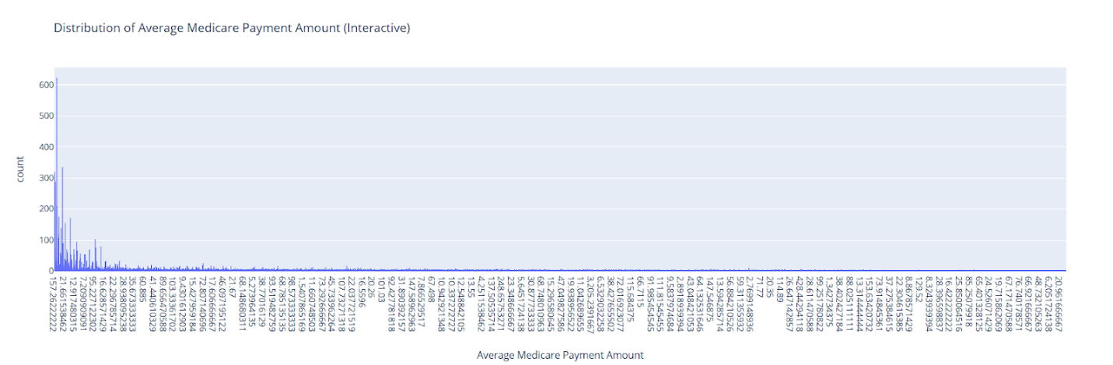

Figure 1. Distribution of Average Medicare Payment Amount (Application Source: Python with Matplotlib)

The distribution analysis indicates that financial variables in the healthcare dataset are highly skewed and have extreme values that may have a great effect on the performance of anomaly detection. In order to learn more about the relations between these characteristics and inform the preprocessing strategy, it is crucial to examine the correlation framework of all the chosen numerical variables.

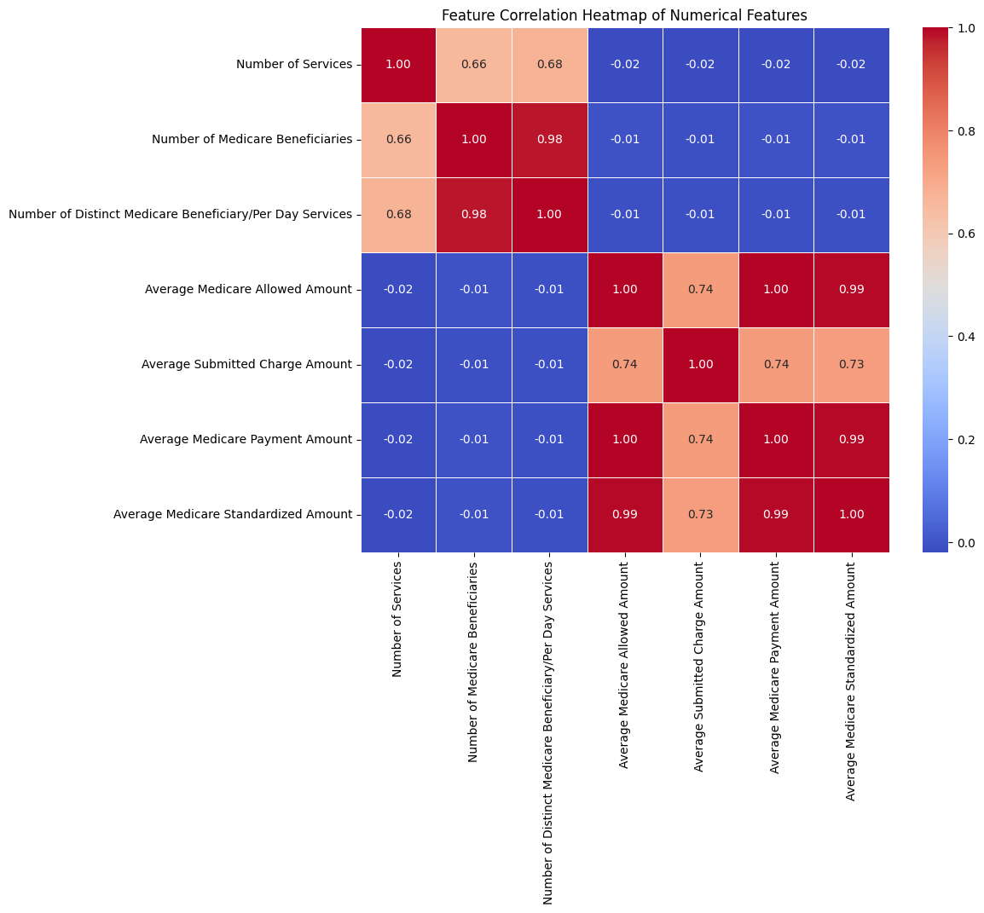
Figure 2. Feature Correlation Heatmap (Application Source: Python with Seaborn)

2.2. Data Preprocessing
To prepare the data for modeling, a series of preprocessing steps were executed. First, the selected numerical columns, initially stored as object types due to formatting characters (e.g., '$', ','), were cleaned and converted to a floating-point numeric format. Subsequently, to ensure that features with larger magnitudes did not disproportionately influence the distance-based or tree-based models, the data was standardized using the StandardScaler method [8]. This common technique transforms each feature to have a mean of zero and a standard deviation of one, as shown in Equation (1).
$z =\frac{\left(x - μ\right)}{σ}$ (1)
where z $(z)$ is the scaled value, x is the original feature value, mu$\left(μ\right)$ is the feature's meaning, and sigma $σ$ is its standard deviation.

2.3. Anomaly Detection Algorithms

2.3.1. Isolation Forest (IF)
Isolation Forest is an ensemble learning algorithm whose idea is that anomalies are few and distinct, and hence more vulnerable to isolation rather than normal points [5]. Being an ensemble technique, it summaries the output of several weak learners to create a stronger model [9]. The algorithm constructs a set of isolation trees(iTrees) on the data set [18]. Data in every tree is recursively split by picking a random feature then a split value, between the minimum and maximum value of that feature. The anomalous points are distinct and therefore are likely to have shorter path lengths of the tree root. The anomaly score of a single example x is the average length of path of x in all trees of the forest, E(h(x)). This is defined by the Equation (2).
$s\left(x, n\right)= 2^{-\frac{E\left(h\left(x\right)\right)}{c\left(n\right)}}$ (2)

where c(n) is a normalization factor representing the average path length of an unsuccessful search in a Binary Search Tree. Scores close to 1 indicate anomalies, while scores much smaller than 0.5 indicate normal points.

2.3.2. Local Outlier Factor (LOF)
Local Outlier Factor is a density-based algorithm that measures the local deviation of a given data point with respect to its neighbors [6]. A point is considered an outlier if its local density is significantly lower than that of its neighbors. The algorithm first computes the local reachability density (lrd) for each point, as shown in Equation (3).

$lrd_{k}\left(A\right)=\frac{1}{\frac{\sum_{B∈N_{k\left(A\right)}}{reach-dist_{k}\left(A,B\right)}}{\left|N_{k\left(A\right)}\right|}}$ (3)
where N_k(A) is the set of k-nearest neighbors of point A. The LOF score is then calculated as the average ratio of the lrd of a point's neighbors to its own lrd, as shown in Equation (4).

$$LOF_{k}\left(A\right)=\frac{\sum_{B∈N_{k\left(A\right)}}{\frac{lrd_{k\left(B\right)}}{lrd_{k\left(A\right)}}}}{\left|N_{k\left(A\right)}\right|}$$
(4)

An LOF score close to 1 indicates that the point is in a region of similar density to its neighbors (inlier), while scores significantly greater than 1 indicate that the point is in a sparser region (outlier). The effectiveness of unsupervised anomaly detection has been validated across multiple domains, with transformer-based approaches showing particular promise in financial market applications [21].

2.4. Model Comparison and Evaluation
To compare the performance and output of the two models, we employed both quantitative and statistical methods. The overlap between the sets of anomalies identified by each model was measured using the Jaccard Index, a standard metric for comparing set similarity [10], as defined in Equation (5).

$J\left(A,B\right)=\frac{\left|A∩B\right|}{\left|A∪B\right|}$ (5)

where A and B are the sets of anomalies identified by two different models. A low Jaccard Index indicates that the models identify different data points as anomalous.
To statistically validate the detected anomalies, we performed hypothesis tests to compare the distributions of features between different groups (e.g., anomalies vs. normal data). The non-parametric Mann-Whitney U test was used for numerical features, as it does not assume a normal distribution of the data [11]. For categorical features, the Chi-square test of independence was used to assess the association between variables [12]. Figure 3 provides a visual summary of this testing strategy. The Chi-square statistic is calculated as shown in Equation (6).
$χ^{2}=\frac{∑{\left(O-E\right)}^{2}}{E}$ (6)

where O is the observed frequency and E is the expected frequency for each cell in a contingency table. A significant p-value (p < 0.05) from these tests suggests that the characteristics of the anomaly group are statistically different from the normal group.
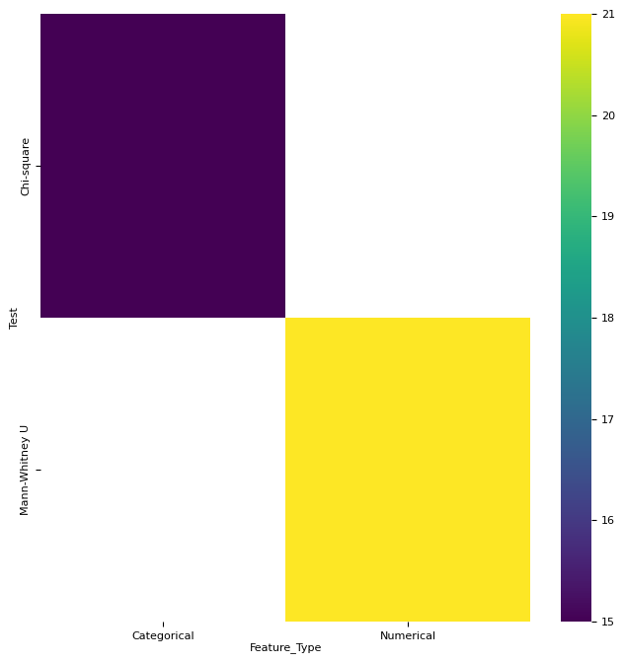
Figure 3: Statistical Test Selection Matrix (Python with Matplotlib/Seaborn)

RESULTS AND DISCUSSION
This section presents the results of the anomaly detection models and gives a discussion of the results. The analysis will center on the number of anomalies identified, their pattern in the feature space, the extent of overlap of the models and a statistical justification of their attributes.

3.1. Anomaly Detection Overview
The Isolation Forest (IF) model, having a contamination parameter of 0.05, found 5,000 records (5.0%) to be of anomaly. The Local Outlier Factor model was estimated in two settings; automatic contamination detection (2,565 records identified (2.56%)) and fixed contamination parameter (0.05), which also identified 5,000 records (5.0%). These baseline counts, summarized in Table 1, are used to compare before and after.

Table 1. Summary of Anomaly Counts by Model
Model | Anomaly Count | Anomaly % | Normal Count
IF (contamination = 0.05) | 5,000 | 5.00% | 95,000
LOF (auto) | 2,565 | 2.56% | 97,435
LOF (contamination = 0.05) | 5,000 | 5.00% | 95,000

3.2. Visualization and Distribution of Anomalies
Visual analysis of the anomalies in the feature space of 'Number of Services' and 'Average Medicare Payment Amount' reveals distinct patterns for each algorithm. As shown in Figure 4, Isolation Forest tends to identify global outliers—data points with extreme values that are far from the central cluster of data. In contrast, Figure 5 shows that LOF, being a density-based method, is more adept at identifying local outliers—points that may not have extreme values but are in sparse, low-density regions of the feature space relative to their immediate neighbors.
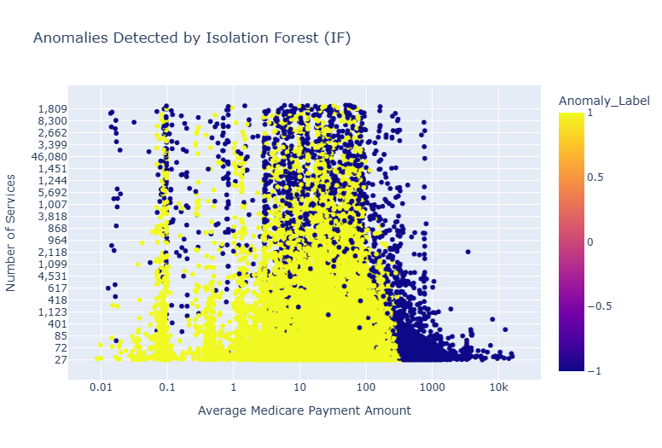
Figure 4: Anomalies Detected by Isolation Forest Scatter Plot (Application Source: Python with Matplotlib/Pandas)
The Isolation Forest algorithm proves useful in identifying global outliers with regard to the scattered anomaly distribution in the feature space. It means that these results suggest that the most characteristic feature of IF is the identification of the points with extreme values which are outliers compared to the central data cluster.
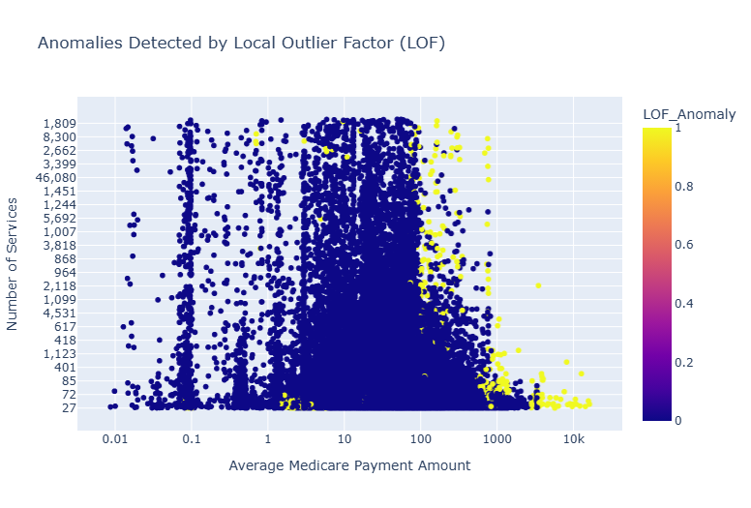
Figure 5: Anomalies Detected by Local Outlier Factor Scatter Plot (Application Source: Python with Matplotlib/Pandas)

3.3. Comparative Analysis of Anomaly Sets
A quantitative comparison of the anomaly sets confirms the visual observations. Venn diagrams (Figure 6) and a confusion matrix heatmap (Figure 7) visually represent the model agreement, while the Jaccard Index (Table 2) provides a quantitative measure. All methods demonstrate a low degree of overlap between the anomalies identified by IF and LOF. When both models used a 0.05 contamination factor, they only agreed on 545 instances, resulting in a Jaccard Index of just 0.058. This low value signifies that the two algorithms are identifying largely different subsets of the data as anomalous. The agreement between the two LOF models was, as expected, much higher (Jaccard Index = 0.513).

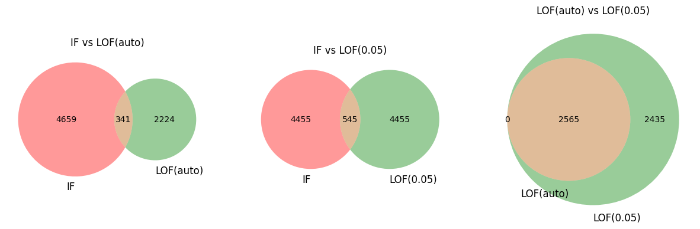
Figure 6: Venn Diagrams of Anomaly Set Overlap (a)IF Vs LOF(Auto) (b) IF Vs LOF(0.05) (c) LOF(auto) Vs LOF(0.05) (Python with matplotlib-venn)

The Venn diagram analysis in Figure 6 clearly illustrates the minimal overlap between anomalies detected by Isolation Forest and Local Outlier Factor, supporting the quantitative findings of low Jaccard Index values. To provide a more comprehensive visualization of this model comparison, a heatmap representation offers additional insights into the distribution patterns and agreement levels between the two algorithms.

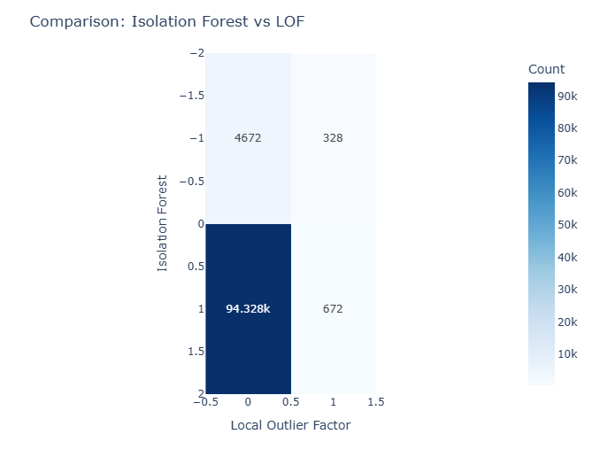
Figure 7: Comparison Heatmap of IF vs LOF (Application Source: Python with Seaborn)

The heatmap visualization in Figure 7 provides a clear representation of the model comparison patterns, highlighting the areas of agreement and disagreement between Isolation Forest and Local Outlier Factor algorithms. The following quantitative analysis presents the precise overlap measurements and Jaccard Index values that support these visual observations.

Table 2. Anomaly Set Overlap and Agreement
Model Pair | Overlap Count | Jaccard Index (Anomalies)
IF vs LOF (auto) | 341 | 0.047
IF vs LOF (0.05) | 545 | 0.058
LOF (auto) vs LOF (0.05) | 2,565 | 0.513

3.4. Statistical Validation of Anomaly Groups
To validate the significance of the detected anomalies, statistical tests were performed. The results, summarized in Tables 3 and 4, show that for nearly all numerical and categorical features tested, there is a statistically significant difference (p < 0.001) between the anomalous group and the normal group. This provides strong evidence that the detected anomalies are not random occurrences but represent a distinct subpopulation within the data. Furthermore, when comparing the anomalies found only by IF against those found only by LOF, statistically significant differences were again observed across all features. This crucial finding confirms that the two models are sensitive to different underlying data characteristics and are capturing fundamentally different types of anomalies.
Table 3. Mann-Whitney U Test Results (Selected Numerical Features)
Comparison | Feature | U Statistic | p-value
Anomaly vs Normal | Number of Services | 5.10e+08 | < .001
Anomaly vs Normal | Avg. Medicare Payment | 5.36e+08 | < .001
IF Only vs LOF Only | Number of Services | 1.21e+07 | < .001
IF Only vs LOF Only | Avg. Medicare Payment | 1.46e+07 | < .001

The output of the Mann-Whitney U test proves that there is a significant statistical difference in numerical characteristics of abnormality and normal groups. Categorical features demand various tests in order to perform the statistical validation. The Chi-Square test outcomes test the pattern of independence and association of categorical data distributions.
Table 4. Chi-Square Test Results (Selected Categorical Features)
Comparison | Feature | χ² Statistic | p-value
Anomaly vs Normal | Provider Type | 7,496.33 | < .001
Anomaly vs Normal | Entity Type | 1,855.13 | < .001
IF Only vs LOF Only | Provider Type | 2,408.72 | < .001
IF Only vs LOF Only | Entity Type | 157.39 | < .001

3.5. Discussion
All of the above outcomes prove the point that both Isolation Forest and Local Outlier Factor are useful in detecting outliers but on different principles, which leads to complementary results. Their disparate success is not due to failure as it is shown by low overlap of their anomaly sets. Isolation Forest is good at detecting global anomalies with extreme feature values, a feature well-documented in the literature of anomaly detection [13], and might be indicative of large-scale billing fraud. LOF on the other hand is sensitive to local anomalies that do not fit into their immediate surroundings, and possibly single out subtle, abnormal patterns of care or specialist providers [14]. Introduction of machine learning algorithm in healthcare applications has continuously demonstrated enhancement of detection accuracy with recent study reaching 98 percent detection of cardiovascular disease with the aid of powerful signal processing methods [22].
This implies that to develop an effective anomaly detection strategy in a complex area such as healthcare, it might not be enough to use one algorithm. An ensemble or a multi-model strategy, which takes advantage of both IF and LOF outputs, may give a more solid and holistic view of possible anomalies [15]. With this kind of a strategy, an investigator can give preference to cases that are known to be both a high-confidence outlier by both models or look at the various types of anomalies that each model can detect on its own to get a bigger picture [23]. The selection of algorithms and parameter optimization as has been shown in recent comparative research is still important in order to optimize the performance of machine learning methods in more complex real-world contexts [24].

CONCLUSION
This paper has effectively implemented and compared two unsupervised anomaly detector algorithms, Isolation Forest and Local Outlier Factor to a large claims dataset of a healthcare provider. This analysis showed that both methods can find statistically significant outliers, but due to their various theoretical underpinnings, these approaches detect different and non-overlapping sets of outliers. A major finding is the low overlap between the sets of anomalies, which was confirmed by a low Jaccard Index and proven by the statistical tests of significance of differences in the characteristics of the sets. It points out that IF is more sensitive to global outliers with extreme values whereas LOF is good at detecting local outliers which are density-based.
A primary limitation of this study is that the pre-labeled anomalies were not available, and it does not allow formal assessment of the precision and recall of the models in detecting real cases of errors or fraud. The contamination parameter selection also has an influence on the detected abnormalities, and extensive parameter tuning was not conducted. Any subsequent work with domain expert validation and labeled data would be essential to a more conclusive view of the effectiveness of the models.
Further research in this area should aim at researching and authenticating the found anomalies, in cooperation with domain experts, to establish their real-life meaning (e.g., error, fraud, or unique practice). This would allow semi-supervised or supervised models to be developed, which in turn have been promising to use limited quantities of labeled data to enhance their performance [17]. Additional future research might also consider other more sophisticated anomaly detection methods, including deep learning-based autoencoders [18], and strive to implement a real-time monitoring system to apply such results to ensure ongoing monitoring of the integrity of the healthcare system [19]. Altogether, the current study presents credible arguments in favor of a multi-model method of anomaly detection in healthcare, which offers a more detailed framework of detecting a broader range of anomalies.

AUTHOR CONTRIBUTIONS
Nyan Lynn Htet: Conceptualization, methodology, writing-original draft, software, validation, visualization. Deshinta Arrova Dewi: Data curation, resources, draft preparation. Mun San Chye: Formal analysis, validation. Marwan Alshare: Validation, writing-review & editing. All authors discussed the results and contributed to the final manuscript.

FUNDING STATEMENT
This research was supported by INTI International University under RMC/10/2026. The authors gratefully acknowledge the financial support that made this study possible.

DECLARATIONS
Competing interest. The authors declare no competing interest.
Conflict of interest. The authors declare that they have no conflicts of interest to report study.

REFERENCES
[1] M. Tabassum, S. Mahmood, A. Bukhari, B. Alshemaimri, A. Daud, and F. Khalique, “Anomaly-based threat detection in smart health using machine learning,” BMC Medical Informatics and Decision Making, vol. 24, no. 347, 2024. doi:10.1186/s12911-024-02760-4

[2] O. Kayode, R. Ullah, F. Halili, C. A. Fernando, A. S. Hapuarachch, and K. Sharma, “AI and Big Data for Fraud Detection in Healthcare Billing Systems,” 2025. https://doi.org/10.13140/RG.2.2.20364.41605

[3] United Nations, Transforming our world: the 2030 Agenda for Sustainable Development, 2015. https://doi.org/10.18356/8fa2e3d7-en

[4] United Nations, “Goal 16: Promote peaceful and inclusive societies for sustainable development, provide access to justice for all and build effective, accountable and inclusive institutions at all levels,” 2025. https://doi.org/10.18356/4a1b01c4-en

[5] F. T. Liu, K. M. Ting, and Z.-H. Zhou, “Isolation Forest,” in *Proceedings of the 2008 Eighth IEEE International Conference on Data Mining*, 2008, pp. 413–422. https://doi.org/10.1109/ICDM.2008.17

[6] M. M. Breunig, H.-P. Kriegel, R. T. Ng, and J. Sander, “LOF: Identifying density-based local outliers,” *ACM SIGMOD Record*, vol. 29, no. 2, pp. 93–104, 2000. https://doi.org/10.1145/335191.335388

[7] T. Selvan, “Healthcare Providers Data for Anomaly Detection,” Kaggle, 2022. https://www.kaggle.com/datasets/tamilsel/healthcare-providers-data

[8] F. Pedregosa, G. Varoquaux, A. Gramfort, V. Michel, B. Thirion, O. Grisel, M. Blondel, P. Prettenhofer, R. Weiss, V. Dubourg, et al., “Scikit-learn: Machine Learning in Python,” *Journal of Machine Learning Research*, vol. 12, pp. 2825–2830, 2011.

[9] L. Rokach, “Ensemble-based classifiers,” *Artificial Intelligence Review*, vol. 33, pp. 1–39, 2010. https://doi.org/10.1007/s10462-009-9124-7

[10] P. Jaccard, “Étude comparative de la distribution florale dans une portion des Alpes et du Jura,” *Bulletin de la Société Vaudoise des Sciences Naturelles*, vol. 37, pp. 547–579, 1901.

[11] H. B. Mann and D. R. Whitney, “On a test of whether one of two random variables is stochastically larger than the other,” Annals of Mathematical Statistics, vol. 18, no. 1, pp. 50–60, 1947.

[12] K. Pearson, “On the criterion that a given system of deviations from the probable in the case of a correlated system of variables is such that it can be reasonably supposed to have arisen from random sampling,” *Philosophical Magazine Series 5*, vol. 50, no. 302, pp. 157–175, 1900. https://doi.org/10.1080/14786440009463897

[13] A. M. A. Fadul, *Anomaly Detection based on Isolation Forest and Local Outlier Factor*, Master’s thesis, Univ. of Duisburg-Essen, Duisburg, Germany, 2023. https://doi.org/10.13140/RG.2.2.17998.43843

[14] H. M. Mohamed, M. Abdallah, H. Refaat, and B. Hafiz, “Integrating LSTM and LOF: A Comprehensive Approach to Anomaly Detection in Healthcare Data,” *Statistics, Optimization & Information Computing*, vol. 13, no. 3, pp. 1245–1265, 2024. https://doi.org/10.19139/soic-2310-5070-2206

[15] A. S. Mirkhail and X. Zhang, “Deep Learning for Anomaly Detection in IoT Healthcare Systems,” *International Research Journal of Multidisciplinary Scope (IRJMS)*, vol. 6, no. 2, pp. 1480–1494, Apr. 2025. https://doi.org/10.47857/irjms.2025.v06i02.03768

[16] S. Kumari, C. Prabha, A. Karim, M. M. Hassan, and S. Azam, “A comprehensive investigation of anomaly detection methods in deep learning and machine learning: 2019–2023,” *IET Information Security*, vol. 19, no. 1, pp. 1–24, 2025. https://doi.org/10.1049/2024/8821891

[17] G. Pang, C. Shen, L. Cao, and A. V. D. Hengel, "Deep learning for anomaly detection: A review," ACM Computing Surveys, vol. 54, no. 2, pp. 1–38, 2021.

[18] M. A. Belay, S. S. Blakseth, A. Rasheed, and P. S. Rossi, “Unsupervised anomaly detection for IoT-based multivariate time series: Existing solutions, performance analysis and future directions,” Sensors, vol. 23, no. 5, p. 2844, Mar. 2023. https://doi.org/10.3390/s23052844

[19] I. H. Sarker, “Machine Learning: Algorithms, Real-World Applications and Research Directions,” SN Computer Science, vol. 2, no. 3, p. 160, 2021
[20] L. Sivagnanam and N. K. Visalakshi, "Enhancing Bipolar Disorder Detection Using Heterogeneous Ensemble Machine Learning Techniques," Journal of Data Science, vol. 2025, no. 01, pp. 1-12, 2025, doi: 10.61453/jods.v2025no01.

[21] K. Biriukova and A. Bhattacherjee, "Using Transformer Models for Stock Market Anomaly Detection," Journal of Data Science, vol. 2023, no. 21, pp. 1-8, 2023, doi: 10.61453/jods.v2023no21.

[22] Y. Padmavathi and R. Ushasree, "Early Detection of Cardiovascular Disease Using Photoplethysmography (PPG) Signal Analysis," Journal of Data Science, vol. 2024, no. 32, pp. 1-8, 2024, doi: 10.61453/jods.v2024no32.

[23] Mustakim, T. B. Kurniawan, Misinem, E. S. Negara, and I. Herdiansyah, "Optimization Algorithms: A Comparison Study for Scheduling Problem at UIN Raden Fatah's Sharia and Law Faculty," Journal of Data Science, vol. 2024, no. 57, pp. 1-19, 2024, doi: 10.61453/jods.v2024no57.
[24] Wang X, Wang Y, Javaheri Z, Almutairi L, Moghadamnejad N, Younes OS. Federated deep learning for anomaly detection on the internet of things. Computers and Electrical Engineering. 2023 May 1;108:108651.

